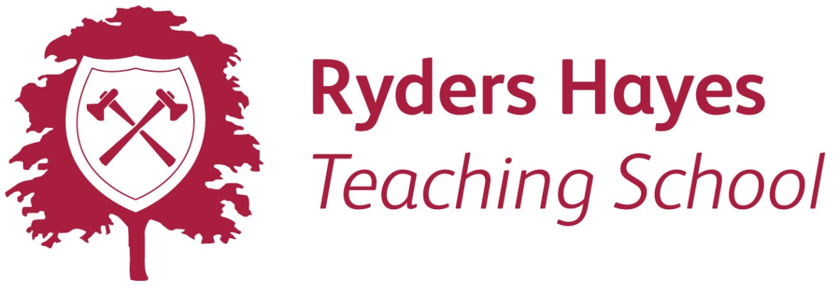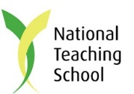

Name of course:
Date of course:
Delegate name:
Job Title:
Email address:
Special requirements:
e.g. dietary needs, accessibility of venue

Parking space required: Y/N

School/organisation name:
School/organisation address:

Postcode:

Telephone:

Further details and directions to the venue will be provided with the confirmation email. The fee includes any course materials and light refreshments.
Purchase order number:
Invoice contact name:
Email address:

Cost per delegate:
Total cost to be invoiced:

Please make cheques payable to: Ryders Hayes School. Thank you
BACS: Ryders Hayes Academy Trust
Lloyds Bank
Sort code: 30-99-06
Account: 32908560
Please quote our invoice number on your BACS remittance.

Terms and conditions:
Course fees are payable in advance. On receipt of your booking form Ryders Hayes Teaching School will invoice you for the full amount. Invoices must be paid in full within 30 days from the date of the invoice or before the course takes place, whichever is sooner. The delegate fee includes course materials if applicable and light refreshments. Lunch is not provided unless stated within your email confirmation. We reserve the right to cancel the booking at any point up until 24 hours before the course takes place, if this happens we will offer you an alternative facilitator, trainer or venue.

Cancellation fees are as follows –
Days to start date | 0-14 days | 15-21 days | 22-28 days | 29 days or more
Charges | 100% | 75% | 25% | 0

No charge will be made for substitution of delegate.

Please return your completed booking form(s) to the address below:
Contact: Julie Tolley
Ryders Hayes Teaching School
Gilpin Crescent
Pelsall
WS3 4HX

Tel: 01922 683008

Email: j.tolley@ryders-hayes.co.uk

Signed ………………………………………………………………………………………….

Dated …………………………………………………………………………………………..

